建置 Debezium cdc

- 建置前預處理
- Logstash目錄結構準備
請在你的專案資料夾下，建立以下的目錄結構與檔案：
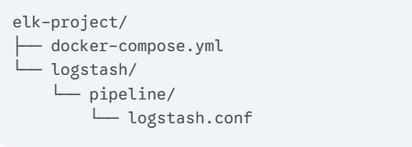
- 建立 logstash.conf (完整內容如附件)
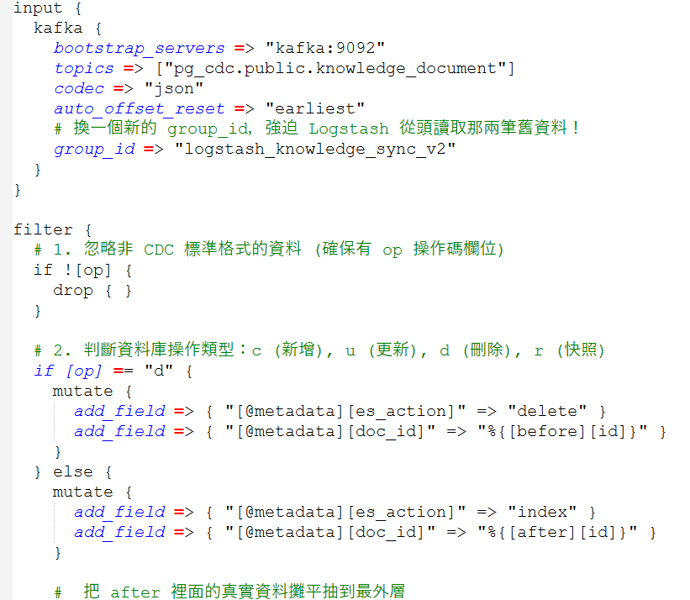

- 建置 docker-compose 容器
- 容器清單:
postgres | elasticsearch
kafka | kibana
kafka-ui | logstash
debezium-connect

- 建立以下 docker-compose.yml (完整內容如附件)
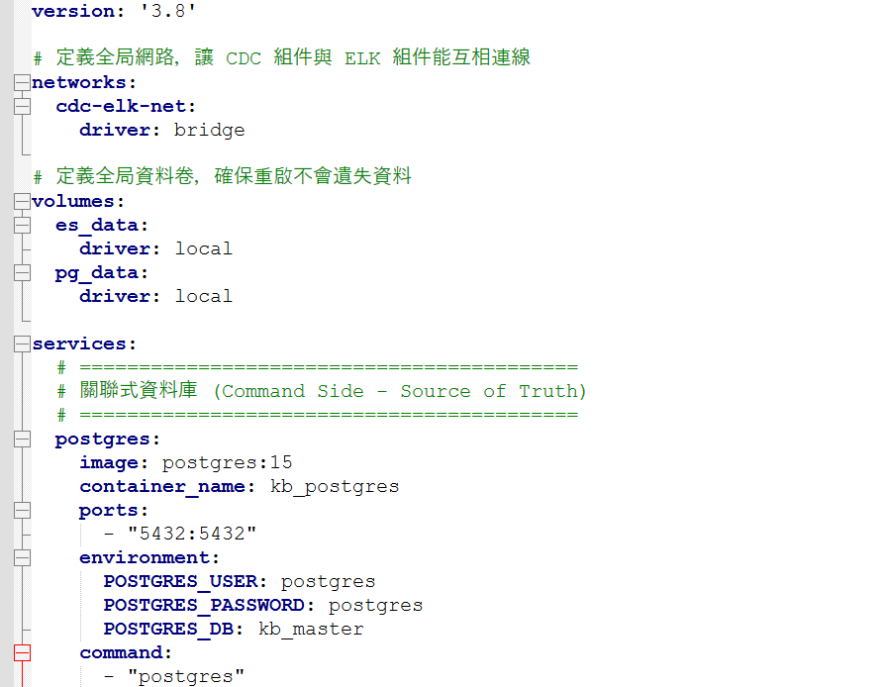

- 執行 Docker Compose 指令
docker-compose up -d

- 進行Debezium 註冊
- 執行以下 SQL建立相關表
-- 1. 建立實體資料表
CREATE TABLE knowledge_document (
id VARCHAR(36) PRIMARY KEY,
title VARCHAR(255) NOT NULL,
content TEXT,
author VARCHAR(100),
category VARCHAR(50),
status VARCHAR(50),
created_at TIMESTAMP,
updated_at TIMESTAMP
);
-- 2. 關鍵：設定 WAL (Write-Ahead Logging) 的層級
-- 這行是告訴 Postgres：「當這張表有任何異動時，請把舊資料跟新資料都寫進日誌裡，讓 CDC 抓得到」
ALTER TABLE knowledge_document REPLICA IDENTITY DEFAULT;

- 透過 Postman 註冊
發送 POST 請求到 http://localhost:8083/connectors/
{
"name": "knowledge-connector",
"config": {
"connector.class": "io.debezium.connector.postgresql.PostgresConnector",
"database.hostname": "kb_postgres",
"database.port": "5432",
"database.user": "postgres",
"database.password": "postgres",
"database.dbname": "kb_master",
"topic.prefix": "pg_cdc",
"table.include.list": "public.knowledge_document",
"plugin.name": "pgoutput",
"snapshot.mode": "initial"
}
}

- 驗證是否建立成功
- 發射子彈 (在 PostgreSQL 寫入資料)
INSERT INTO knowledge_document ( id, title, content, author, category, status, created_at, updated_at ) VALUES ( 'doc-uuid-001', 'CDC 實戰驗證：第一滴血', '如果你能在 Elasticsearch 看到這句話，代表 Debezium 到 Logstash 的任督二脈已經徹底打通了！', 'Nick', 'TECH_SPEC', 'PUBLISHED', NOW(), NOW() );

- 檢查運輸車隊 (透過 Kafka UI 觀察訊息)
資料寫入 DB 的瞬間，Debezium 應該已經抓到並丟進 Kafka 。我們來視覺化地確認這件事：
- 打開瀏覽器，進入你的 Kafka 儀表板：http://localhost:8028
- 驗證點 1： 是否有看到一個名為pg_cdc.public.knowledge_document 的 Topic？如果有，代表 Debezium 註冊成功，並自動建立了通道！
- 點擊該 Topic，切換到 Messages 頁籤。
- 驗證點 2： 應該會看到一筆剛進來的 JSON 訊息。

- 檢查加工廠 (觀看 Logstash 日誌)
Logstash 負責把 Kafka 裡肥大的 CDC 封包「拆信封」，並轉成乾淨的格式。
- 打開終端機 (CMD / Terminal)。
- 輸入指令查看 Logstash 的即時日誌：
docker logs -f kb_logstash
看到以下訊息代表建置成功:
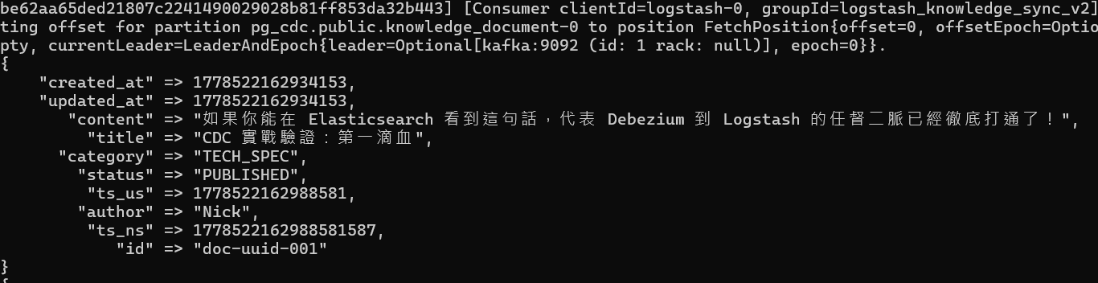

- 抵達 Query 端 (在 Kibana / ES 搜尋)
這是我們系統對外的最終展示點，使用者要來搜尋了！
- 打開瀏覽器，進入 Kibana： http://localhost:5601
- 點擊左側選單的 Dev Tools（開發工具，圖示像個小扳手）。
- 在左邊的輸入框打上：
GET knowledge_base/_search
看到以下代表順利建置成功
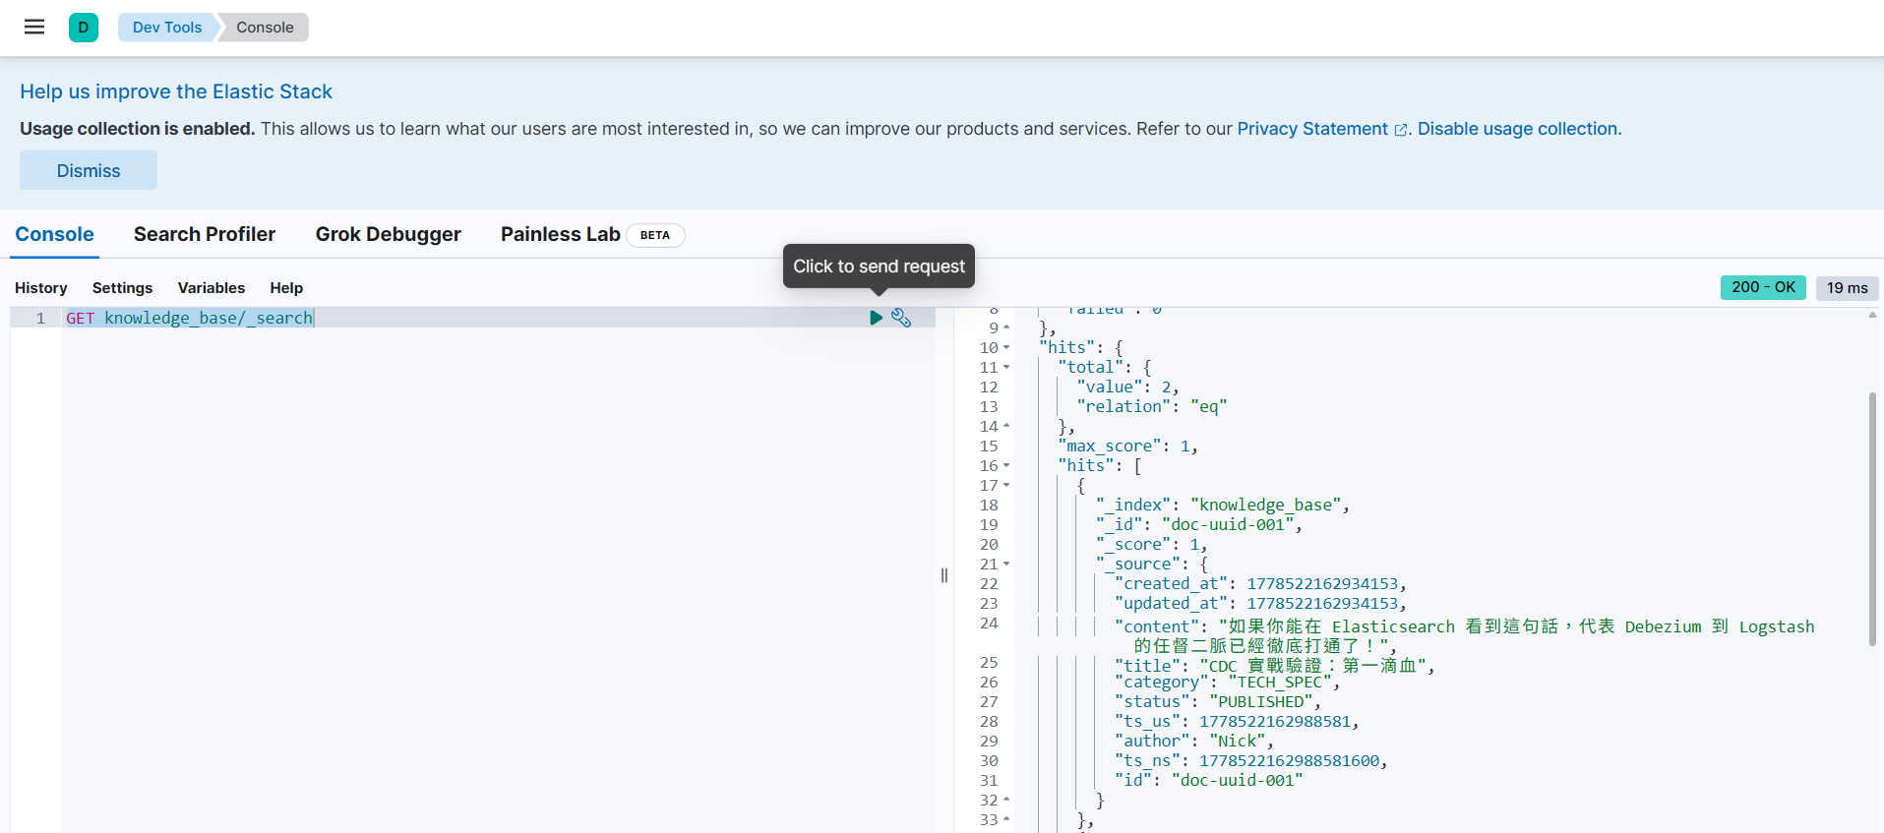

- 附錄:
logstash.conf
input {
kafka {
bootstrap_servers => "kafka:9092"
topics => ["pg_cdc.public.knowledge_document"]
codec => "json"
auto_offset_reset => "earliest"
# 換一個新的 group_id，強迫 Logstash 從頭讀取那兩筆舊資料！
group_id => "logstash_knowledge_sync_v2"
}
}

filter {
# 1. 忽略非 CDC 標準格式的資料 (確保有 op 操作碼欄位)
if ![op] {
drop { }
}

# 2. 判斷資料庫操作類型：c (新增), u (更新), d (刪除), r (快照)
if [op] == "d" {
mutate {
add_field => { "[@metadata][es_action]" => "delete" }
add_field => { "[@metadata][doc_id]" => "%{[before][id]}" }
}
} else {
mutate {
add_field => { "[@metadata][es_action]" => "index" }
add_field => { "[@metadata][doc_id]" => "%{[after][id]}" }
}

# 把 after 裡面的真實資料攤平抽到最外層
ruby {
code => "
after_data = event.get('after')
if after_data
after_data.each { |k, v| event.set(k, v) }
end
"
}
}

# 3. 清理不需要的 CDC 系統欄位，保持 ES 資料乾淨
mutate {
remove_field => ["before", "after", "source", "op", "ts_ms", "transaction", "@version", "@timestamp", "message", "event"]
}
}

output {
elasticsearch {
hosts => ["http://elasticsearch:9200"]
index => "knowledge_base"
action => "%{[@metadata][es_action]}"
document_id => "%{[@metadata][doc_id]}"
}

stdout {
codec => rubydebug
}
}

docker-compose.yml
version: '3.8'

# 定義全局網路，讓 CDC 組件與 ELK 組件能互相連線
networks:
cdc-elk-net:
driver: bridge

# 定義全局資料卷，確保重啟不會遺失資料
volumes:
es_data:
driver: local
pg_data:
driver: local

services:
# ==========================================
# 關聯式資料庫 (Command Side - Source of Truth)
# ==========================================
postgres:
image: postgres:15
container_name: kb_postgres
ports:
- "5432:5432"
environment:
POSTGRES_USER: postgres
POSTGRES_PASSWORD: postgres
POSTGRES_DB: kb_master
command:
- "postgres"
- "-c"
- "wal_level=logical" # 開啟邏輯複製 (CDC 必備)
- "-c"
- "max_wal_senders=10"
- "-c"
- "max_replication_slots=10"
volumes:
- pg_data:/var/lib/postgresql/data
networks:
- cdc-elk-net

# ==========================================
# 訊息佇列 (Kafka KRaft 模式 - 免 Zookeeper)
# ==========================================
kafka:
image: confluentinc/cp-kafka:7.5.0
container_name: kb_kafka
ports:
- "9092:9092"
environment:
KAFKA_NODE_ID: 1
KAFKA_PROCESS_ROLES: broker,controller
KAFKA_LISTENERS: PLAINTEXT://0.0.0.0:9092,CONTROLLER://0.0.0.0:9093
KAFKA_ADVERTISED_LISTENERS: PLAINTEXT://kafka:9092
KAFKA_CONTROLLER_LISTENER_NAMES: CONTROLLER
KAFKA_LISTENER_SECURITY_PROTOCOL_MAP: CONTROLLER:PLAINTEXT,PLAINTEXT:PLAINTEXT
KAFKA_CONTROLLER_QUORUM_VOTERS: 1@kafka:9093
KAFKA_OFFSETS_TOPIC_REPLICATION_FACTOR: 1
KAFKA_TRANSACTION_STATE_LOG_REPLICATION_FACTOR: 1
KAFKA_TRANSACTION_STATE_LOG_MIN_ISR: 1
KAFKA_GROUP_INITIAL_REBALANCE_DELAY_MS: 0
CLUSTER_ID: MkU3OEVBNTcwNTJENDM2Qk
networks:
- cdc-elk-net

# UI 管理介面 - 觀測 Kafka Topic 與訊息
kafka-ui:
image: provectuslabs/kafka-ui:latest
container_name: kb_kafka_ui
depends_on:
- kafka
ports:
- "8028:8080"
environment:
KAFKA_CLUSTERS_0_NAME: local
KAFKA_CLUSTERS_0_BOOTSTRAPSERVERS: kafka:9092
networks:
- cdc-elk-net

# ==========================================
# CDC 異動資料擷取 (Debezium)
# ==========================================
debezium-connect:
image: debezium/connect:2.6
container_name: kb_debezium_connect
depends_on:
- kafka
- postgres
ports:
- "8083:8083" # 開放給 REST API 註冊 Connector 用
environment:
BOOTSTRAP_SERVERS: kafka:9092
GROUP_ID: 1
CONFIG_STORAGE_TOPIC: debezium_connect_configs
OFFSET_STORAGE_TOPIC: debezium_connect_offsets
STATUS_STORAGE_TOPIC: debezium_connect_status
CONNECT_KEY_CONVERTER: org.apache.kafka.connect.json.JsonConverter
CONNECT_VALUE_CONVERTER: org.apache.kafka.connect.json.JsonConverter
CONNECT_KEY_CONVERTER_SCHEMAS_ENABLE: "false"
CONNECT_VALUE_CONVERTER_SCHEMAS_ENABLE: "false"
networks:
- cdc-elk-net

# ==========================================
# 全文檢索與日誌平台 (Query 端)
# ==========================================
elasticsearch:
image: docker.elastic.co/elasticsearch/elasticsearch:8.12.2
container_name: kb_elasticsearch
environment:
- discovery.type=single-node
- xpack.security.enabled=false
- "ES_JAVA_OPTS=-Xms512m -Xmx512m"
ports:
- "19200:9200"
volumes:
- es_data:/usr/share/elasticsearch/data
networks:
- cdc-elk-net

kibana:
image: docker.elastic.co/kibana/kibana:8.12.2
container_name: kb_kibana
environment:
- ELASTICSEARCH_HOSTS=http://elasticsearch:9200
ports:
- "5601:5601"
depends_on:
- elasticsearch
networks:
- cdc-elk-net

logstash:
image: docker.elastic.co/logstash/logstash:8.12.2
container_name: kb_logstash
environment:
- "LS_JAVA_OPTS=-Xms256m -Xmx256m"
ports:
- "5000:5000"
volumes:
- ./logstash/pipeline:/usr/share/logstash/pipeline:ro
depends_on:
- elasticsearch
networks:
- cdc-elk-net

